TITLE
BCODE Configuration




- Add new BCODE button in TSConfig(ZTransight-Payment Screen) and call pre_BCODE.vbs

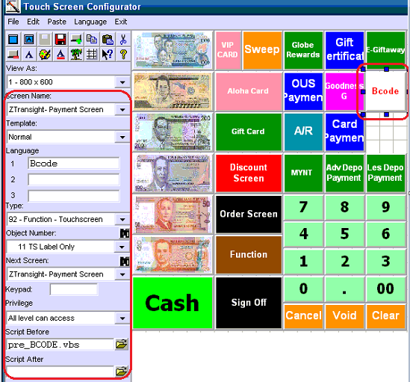

- Go to Tender Media and Add the BCODE

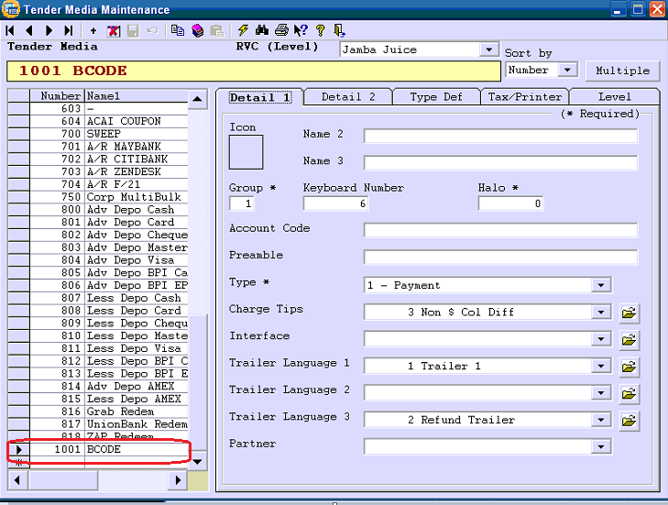
Needs to enable in Type Def
- 4,12,13,22, 28, 30, 34
Tax/printer
- Enabled 1and 2 in printer

- Kindly Add the BCODE in tracking maintenance.
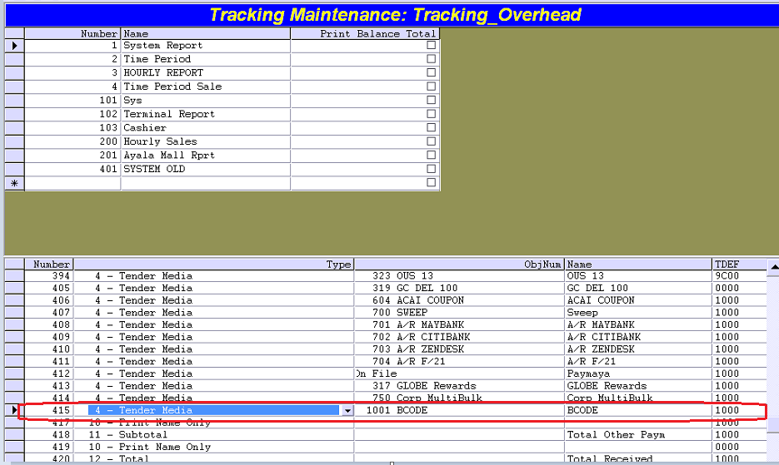

For POS

- Go to c:\dtspos\ CESAgent
- Rename CESAgent to OLDCESAgent
- Copy and paste new CESAgent in c:\dtspos\
- Go to c:\dtspos\CESAgent\CESAdoptor
- Click and run register.bat

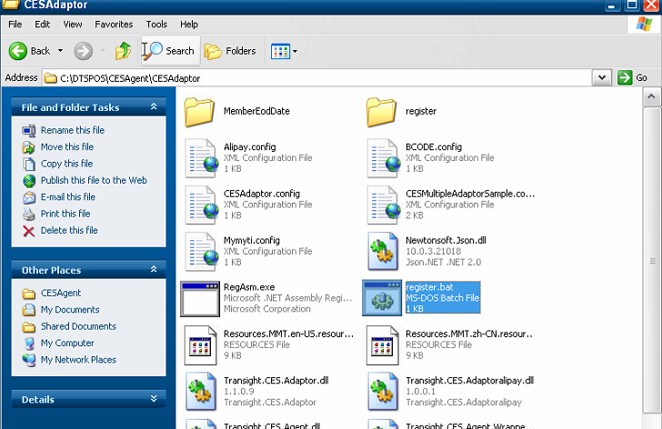

For POS script
- Please make it sure to backup whole script in c:\dtspos\script
- Copy and paste below script
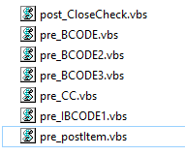
- Changed the printer ID in post_CloseCheck
- You may check the printer ID on the OLD script(post_CloseCheck)
- Please change the number below based on trailer maintenance
